**Spatial modelling and estimation of mammals’ mortalities by Pantanal 2020 megafires**

**ABSTRACT**

1. Extreme wildfires events with unprecedented regimes and scales, such as the Pantanal 2020 megafires, are expected to become more common. Although understanding the impacts of such extreme events on wildlife is imperative for conservation planning, these impacts are rarely addressed explicitly from direct observations of deaths.
2. Here, we use double-observer carcass surveys to assess the numbers and spatial patterns of direct mortalities of medium- to large-sized mammals resulting from the Pantanal 2020 megafires, accounting for imperfect detection. We model the spatial variation in mortality occurrence and abundance, testing the effects of habitat-related variables and wildfire severity using multi-species N-mixture models.
3. We found that 26 out of 27 species of medium and large-sized mammals and died by the fires with a mean estimate of around 49 thousand individuals. The most affected species included capuchin monkeys, agoutis, peccaries, tapirs, brocket deer, tamanduas, coatis, and capybaras.
4. Direct mortality of mammals by wildfires were affected by landscape factors related to species habitats, species traits (probably related to escape or refuge strategies) and also the intensity of the wildfires. Mortalities presented a general positive relationship with non-flooded forests (a fire-sensitive habitat in Pantanal) and with wildfire severity. Artificial water bodies, a common landscape structure in Pantanal, had 7.5 times more deaths than other areas.
5. *Synthesis and applications*: With the used approach, we were able to: i) estimate direct wildfire mortality, reveal mortality relationships with landscape features and identify mortality hotspots; and ii) simultaneously identify the most affected species and assess the assemblage mean relationships. This leads to conservation and management planning in two-fold, species prioritization for rescuing and monitoring, and territory prioritization for fire prevention and fighting.

Keywords: Brazil, carcass surveys, climate change, double observers, hierarchical model, imperfect detection, wildfires

**INTRODUCTION**

Wildfires are a major force shaping several terrestrial ecosystems worldwide and influencing the evolution of plants and animals (Bond & Keeley, 2005; Pausas & Keeley, 2009; Pausas & Parr, 2018). Animals can be affected by wildfires directly being killed or injured by the flames, heat, or smoke; or indirectly, by starvation driven by the resource unavailability or by an increase in predation (first- and second-order effects, respectively; Engstrom, 2010). Species that evolved in fire-prone ecosystems typically present some responses to avoid the effects of fires, such as seeking shelter in burrows or water bodies and fleeing away (Nimmo et al., 2021). Although wildfires are considered an important driver for the diversification of life, their frequency and magnitude in fire-prone ecosystems are increasing considerably as the occurrence of extreme events becomes more frequent with global climate changes (Jolly et al., 2015; Linley et al., 2022; Nimmo et al., 2021; Pausas & Keeley, 2021). Furthermore, the combination of extreme events of heat waves and severe droughts with the spreading presence of humans in many ecosystems increases the occurrence of fire events, resulting in megafires with unprecedented regimes (Duane et al., 2021; Linley et al., 2022; Pausas & Keeley, 2021). Hence, responses of animals to wildfires, which evolved over thousands or millions of years, may suddenly become inefficient to these larger and faster megafire events (Nimmo et al., 2021; Pausas & Keeley, 2009).

The impacts of wildfires on animals tend to be spatially heterogeneous since the density of individuals might vary in space, and fires behave diversely depending on landscape configuration. Information on species occurrence or abundance is commonly used to infer the effects of wildfires on animals (Ward et al., 2022). However, these two variables may not be the only factors shaping the distribution of deaths. For example, the availability of escape routes and distribution of shelters, such as burrows and water bodies, can determine the survival chance of individuals (Robinson et al., 2013). Wildfires behave differently according to the temperature, wind, vegetation type, humidity, and spatial configuration of fuel load. In addition, the flames’ size and speed may result in different levels of severity. Species also present different escape behaviors (e.g., climbing up trees, burrowing, or running away) and have different capacities to escape according to their vagility during fires (Nimmo et al., 2021). Hence, the spatial patterns of species’ mortality by wildfires would result from spatial variation in species density, availability of refugees and escape routes, and wildfire characteristics (Jolly et al., 2022). Although all these factors have been discussed in the literature, their effects are rarely evaluated directly.

Assessing patterns of animal mortality from megafires highlights the potential effects of such extreme events on population dynamics. Notably, very few studies evaluate the direct impacts of wildfires under extreme events such as megafires (Jolly et al., 2022). The impact of wildfires on animals is usually addressed based on information that overlaps the species occurrence or density with areas burnt or habitats affected (e.g., Ward et al., 2022), or comparisons of some populational variable of interest (e.g., occupancy or abundance) before and after the fires or burnt and unburnt areas (Driscoll et al., 2010). However, the direct observation of the distribution of carcasses can give more accurate information on mortality heterogeneity and its association with spatial features. Given the inherent imperfections of any ecological sampling methods, assessing wildfire mortality patterns from carcass surveys necessitates the use of robust approaches that take into account potential observation errors. If such sources of error are not considered, impacts of wildfires can be underestimated. For instance, to our knowledge, Tomas et al. (2021) conducted the only study that accounts for imperfect detection during wildfire carcass surveys using transect distance samplings to estimate vertebrate mortality densities after fires in Pantanal, Brazil.

The Pantanal wetland – the world’s largest tropical wetland, located in Central South America (Junk et al., 2006)– is a seasonal fire-prone ecosystem that has received international attention because of the unprecedented massive wildfires of 2020 (Libonati et al., 2020). It is a vast biodiverse region, presenting the largest populations of several wildlife species, including mammals threatened with extinction (e.g., tapirs, white-lipped peccaries, marsh deer, giant anteaters, giant armadillos, and giant otters), thus standing as a reservoir of their genetic diversity (Alho et al., 2011). Historically, non-anthropogenic wildfires in Pantanal are started by lightning strikes and occur in the transition between the dry and wet seasons (Menezes et al., 2022). Now, this ecosystem is threatened by the increasing frequency of extreme events of megafires. This new scenario is related to more severe droughts and an escalation of anthropogenic ignitions during the peak of the dry season because of land use intensification (Ferreira Barbosa et al., 2022; Leal Filho et al., 2021; Marques et al., 2021). Severe weather conditions in 2019 and 2020, such as high temperatures, reduced precipitation, and diminished soil moisture, combined with a higher number of fire foci in private lands (encouraged by a weak national environmental protection policy in Brazil) resulted in the Pantanal 2020 megafires (Ferreira Barbosa et al., 2022; Garcia et al., 2021; Leal Filho et al., 2021). The fires affected about one-third of the Pantanal area, that is, almost four million hectares (Libonati et al., 2021). With the predicted increase of extreme climatic events in the following years (Marengo et al., 2016), such as the 2020 megafires, the role of Pantanal as a biodiversity sanctuary is threatened. Hence, there is a need to understand the impacts of such events on wildlife. An assessment of the mortality from the 2020 megafires in the Pantanal wetland estimated that around 17 million vertebrates died due to the wildfires (Tomas et al., 2021). Despite the alarming and relevant results of that study, it was conducted in an extensive and general context, not assessing the effects of the intrinsic spatial heterogeneity of the Brazilian Pantanal. Addressing the potential associations of mortalities with different landscape features have an uttermost importance to support and prioritize preventive actions.

Here, we aim to assess the numbers and spatial patterns of direct mortalities of medium- to large-sized mammals resulting from the Pantanal 2020 megafires. For this, we conducted double-observer carcass surveys at a large reserve in Pantanal (Brazil) and analyzed the carcass count data with multi-species (“community”) N-mixture models. We considered spatial heterogeneity in carcass occurrence and abundance, testing the effects of habitat-related variables and wildfire severity. We also explored the effects of spatial variation on the carcass detection probability by observers. We specifically tested four hypotheses on the effects of spatial heterogeneity in the variation of mortality and one in the variation of detection probability: i) considering that non-flooded forests are high-quality habitats for medium-large size mammals in Pantanal (Cid et al., 2013; Desbiez et al., 2009; Hofmann et al., 2016; Keuroghlian et al., 2009; Regolin et al., 2021; Trolle et al., 2008), these areas would probably concentrate more deaths; ii) areas closer to water bodies would present fewer carcasses because they could be used as refuges by the animals; iii) wildfire severity would positively impact the number of mammal carcasses; iv) small artificial water bodies that dry up in years of severe drought may act as ecological traps during fires and thus would concentrate more deaths; and v) carcass detection would be affected by the amount of non-burnt vegetation. Finally, we produced spatial predictions to get the total number of mortalities, mortality densities, and mortality richness of medium-large sized mammals directly affected by the 2020 megafires, as well as identify core areas of mortality distribution.

**MATERIALS AND METHODS**

*Study area*

We developed this study in the Sesc (Social Service of Commerce) Pantanal Private Natural Reserve, a Ramsar site (number 1270) in the Northern Brazilian Pantanal wetland (Figure 1). Encompassing an area of 108,000 hectares, the reserve is situated in the municipality of Barão de Melgaço in the Midwest of Brazil (16º 45’ S; 56º 15’ W). It is limited by two major rivers of the Alto Paraguay River Basin, the Cuiabá River in the west and the São Lourenço River in the east. The regional climate, according to the Köppen climate classification is "Aw", typical of a savannas, with high temperatures throughout the year (monthly means >22°C) and a dry winter (Hofmann et al., 2010). The total annual rainfall is around 1,200 mm, with the rainy season concentrated between November and March and a pronounced dry season between the second half of May and the end of September (Hofmann et al., 2016). During the wet season, the area is flooded by the overflows of the nearby rivers. The reserve comprises a highly heterogeneous mosaic of vegetation types, mainly structured by soil characteristics and microrelief differences that are exposed to different flooding regimes. The western portion of the reserve is more humid and exposed to great variations in flooding water levels. It is mainly covered by shrublands, seasonally flooded forests (*Vochysia divergens* monodominated forests;Vochysiaceae), and riparian forests. Riparian and seasonally dry forests characterize the eastern portion, while the central region is a heterogeneous mosaic, mainly composed of patches of grassland, woody “cerrado” vegetation, and dry forests. Since the creation of the reserve in 1997, cattle have been excluded and the managers have fought wildfires. Approximately 60 cattle watering holes (artificial water bodies, AWB hereafter, Figure 1c) have remained in the area, built when the region was used for cattle ranching. The 2020 Pantanal megafires hugely impacted the Sesc Pantanal Reserve region. The wildfires started outside the reserve, reaching its northern and southern limits in early August 2020. There were 43 days of firefighting by the reserve’s fire brigade, but 100,980 ha (~93% of the area) had burnt until mid-September, corresponding to an average propagation speed of 2,511 ha/day.

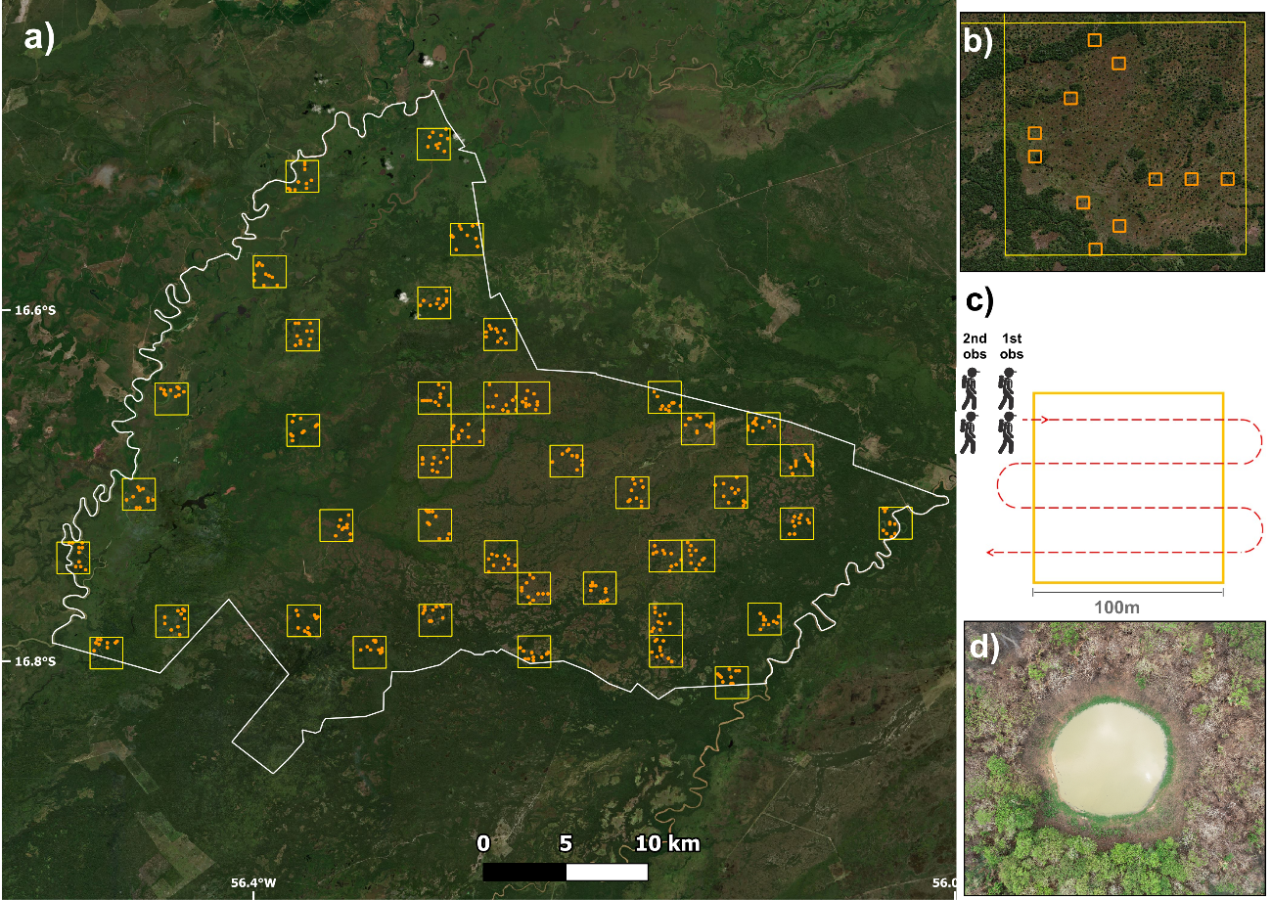

**Figure 1.** Study area and carcass sampling design. (a) Sesc Pantanal Reserve (white contour) with the 42 (yellow contours) 2x2 km quadrats randomly displaced, (b) containing approximately 10 (orange contours) 1 ha plots where (c) medium and large-sized mammals’ carcasses were searched using a dependent double observer protocol. (d) Example of artificial water body present in the region, remnant from the time it was composed of cattle ranches.

*Carcass surveys*

We conducted carcass surveys from September (with the last fires in the reserve still occurring) until November 2020. We adopted 1 ha plots (100x100 m) as the sample units (i.e., sites) in which carcasses were searched. To facilitate fieldwork logistics, we defined the location of the sites in a hierarchical randomization. First, we randomly located 42 quadrats of 2x2 km (10 with and 32 without AWB) within the reserve and then randomly located approximately ten plots of 1 ha per quadrat (Figure 1). This process ended up with 423 sites, 14 of them containing artificial water bodies. At each site, surveys were carried out by walking the entire 1 ha plot using a dependent double-observer protocol (Figure 1d). That is, the front survey team was the first observer and recorded all detected carcasses, while the back team (second observer) recorded only the carcasses missed by the front team. Front and back teams were usually consisted of two people each. Since the field of view changed according to vegetation obstruction, the distance between lines was greater in sites with open vegetation and shorter in closed-vegetation sites, commonly varying from five to ten meters.

During surveys, we focused the searches on carcasses of medium- and large-sized vertebrates (>1 kg), especially mammals, but we recorded all species, irrespective of size. We considered 28 species of medium- and large-sized mammals known to occur in the area for the analysis (Table S1). Since both brocket deer species were considered a single taxon for identification purposes, we analyzed 27 taxa. We assumed that carcass losses by complete incineration or scavenger removal were insignificant for these species. This assumption could be empirically confirmed because we followed some carcasses during the fieldwork and they remained in the exact same place during the study period. Some of them were detected until three years later the fires. Detected carcasses were recorded using a smartphone app (Kobo Toolbox; www.kobotoolbox.org/), in which we annotated the probable species (identified on the site for later verification), geographical coordinates, pictures, and if the first or second observer detected it. Recorded carcasses with evidence of bone abrasions or covered by soil were assumed to be already present before wildfires and thus were discarded. The taxonomical identification of the carcasses, as well as their age-classes (before or after fire), were made posteriorly by experts through comparison of their photographic record with museum specimens. For the mammal species considered, we had a low proportion of uncertain identifications that were discarded (<3%).

*Covariates*

We used the proportion of non-flooded forest (NFforest; Figure S1), distance to water bodies (dist2water; Figure S2), wildfire severity (dNBR; Figure S3), presence of artificial water bodies (AWB) and proportion of green vegetation (greenVeg) as predictor variables. First, non-flooded forests were extracted from a land use and cover classification of 2016 for the Sesc Pantanal Reserve region by joining the classes of seasonally dry forests and evergreen riparian forests. The remaining classes (shrubland, flooded forests, and grasslands) were grouped into another category. This land use and cover map was produced under a supervised classification of Landsat scenes (30x30 m) using images from three periods of the year (rainy season, discharging low water season, and dry season) and eight classes (water bodies, shrubland, flooded forest, seasonally dry forest, evergreen/riparian forest, grassland with earth mound woody vegetation, i.e., “campo com murundus”, seasonally dry forest with bamboo).

We extracted the water bodies using the Water in Wetlands index (WIW; Lefebvre et al., 2019) applied to the bands B8a (near-infrared) and B12 (short-wave infrared) of a Sentinel-2 scene (20x20 m) from September 2019. Then, we generated a raster with the same resolution, containing the distance to the closest permanent water body for each cell. Wildfire severity was calculated using the difference Normalized Burn Ratio (dNBR) based on the bands B8a (near-infrared) and B12 (short-wave infrared). The dNBR is used to highlight burned areas and estimate the burn severity of wildfires by calculating the difference in the normalized burn ratio between images immediately before and after the fires. This index results in a continuous severity scale ranging from unburnt areas to the most severely burnt. To represent the pre-fire period, we used scenes from the last half of June 2020 and, to post-fire, scenes from the first half of October 2020. We processed the dNBR index at Google Earth Engine (see the code at https://code.earthengine.google.com/ae0fe8e50b488c20deb75037a08709a1).

To characterize the vegetation obstruction at each 1 ha plot (Figure S4), we estimated the proportion of green vegetation from an aerial drone picture taken perpendicular to the ground at 110 m height using a DJI Phantom 4 Pro (ground sampling distance = 3cm/px). The green vegetation in drone images was calculated using a Fractional Green Canopy Cover provided by the Canopeo application (Patrignani & Ochsner, 2015).

*Mortality estimation and modeling*

We used N-mixture models – a family of hierarchical models for count data of unmarked populations – to analyze the data (Dénes et al., 2015; Kéry & Royle, 2016). We fitted the dependent double-observer counts for each species $k∈\{1,..,K=27\}$ in each site $i∈\{1,..,S=423\}$ using an N-mixture model with a zero-inflated Poisson distribution and considering species as a random effect variable (i.e., Multi-species Zero-inflated N-mixture model with dependent double observers; derived from Yamaura et al., 2016). We applied a Bayesian approach using JAGS (Plummer, 2003) from software R (R Core Team, 2022) through the jagsUI package (Kellner, 2015).

The input data are a 3-dimensional array (*S* x 2 x *K*) containing the counts of each observer (front and back teams) for each species at each site. First, we used a data augmentation approach, restricted to the 27 species of the regional pool that are known to occur in the Sesc Reserve (“super-community”) to account for the unobserved species in the total mortality and richness estimates (Dorazio et al., 2006). For this, we added all-zero matrices in the *K* dimension for those species from the regional pool that were never detected at any site. Then, we specified a species indicator variable $ω_{k}$ defined by a Bernoulli distribution, where each species *k* from the regional pool has an inclusion probability θ of being present at any site. To account for the large proportions of zeros in the count data, we included a zero-inflated level (i.e., a latent suitability indicator variable), in which each present carcass species *k* is suitable to occur in a given site *i* with a probability $ψ$ (hereafter suitability probability).

$$a_{ik} \sim Bernoulli(ψ.ω_{k})$$

The carcass abundance of each species in each site, *Nik*, is governed by a Poisson distribution with an expected local abundance $λ$ (note that the local abundance can be zero) and conditional on the suitability indicator $a_{ik}$:

$$N_{ik} \sim Poisson(λ.a_{ik})$$

Finally, assuming that each carcass of the local population *Nik* has a probability *p* of being detected by the first observer (front team) and a probability $\left(1-p\right)p$ of being detected by the second observer (back team), we modeled the detection probability by each observer in each site using a multinomial observation process. Then, the count data *Cijk* of each observer *j $∈\{1,2\}$* , for each species *k*, at each site *i*, is modeled as a function of multinomial conditional cell probabilities πj:

*,* where $π_{i1k}=p$ and $π_{i2k}=\left(1-p\right).p$.

Here, we interpret the suitability probability $ψ$ similarly (but not equally) to a carcass “occurrence” process, but note that nonoccurrences (zeros) can also arise from the Poisson distribution in the local abundance process. Variation (i.e., heterogeneity) in the basic parameters can be modeled as a linear function of covariates using the appropriate link functions, such as logit for the suitability $ψ$ and detection probabilities *p* and log for the expected local abundance $λ$. Importantly, this model structure assumes that carcass losses by scavengers or incineration are insignificant (see the previous section).

To model the variation in the carcass suitability probability $ψ$, we included the effects of non-flooded forests and distance to water bodies. As different species may respond differently to the two variables, we considered species random effects in both the linear intercept and slope using normal distributions:

$\operatorname{logit}{(ψ_{ik})}= β_{0k}+ β_{1k}.{NFforest}_{i}+ β_{2k}.{dist2water}_{i}$,

where for each of those coefficients: $β_{k} \sim Normal(μ_{β}; σ_{ β}^{2})$. This approach with multi-species random effects permits estimating the mean “community” effects of each covariate (from the hyper-parameters $μ_{β}$) while providing more precise estimates for single species relationships since the species with more information “borrow” information for species with less (Dorazio et al., 2006; Muñoz et al., 2018). We used a Bayesian latent indicator scale selection (BLISS; Stuber et al., 2017) to fit and select the spatial scale for the non-flooded forest effect. In such an approach, a latent indicator variable is defined with the same length of the number of scales in the predictor variable ${sc}_{l}∈\{1,..,L=6\}$ (corresponding to the six scales: 0m, 200m, 400m, 600m, 800m, 1000m) and governed by a categorical distribution. Then, this scale indicator variable is used to “choose” the appropriate scale for the predictor variable matrix by modifying the formula above $β_{1k}.{NFforest}_{i{ sc}_{l}}$.

We included the linear effects of wildfire severity (dNBR) and artificial water bodies (AWB) on the expected carcass abundance $λ$ similarly to the suitability probability but considering the species random effect only for the intercept parameter:

$\log{(λ_{ik})}= α_{0k}+ α_{1}.{NBR}_{i}+ α_{2}.{AWB}_{i}$, where $α_{0k} \sim Normal(μ_{α0}; σ_{ a0}^{2})$.

Finally, we modeled the variation in the detection probability, including the linear effect of green vegetation at the sites and considering species random effects only in the intercept. We first ran the model with all covariates and effects (i.e., ψ(NFforest + dist2water) λ(dNBR + AWB) *p*(greenVeg)) and then ran the final model without the covariates that did not present effects on the parameters (i.e., credibility intervals overlapping zero). We excluded the species random effect from the intercept of detection probability because it resulted in very uncertain and unreliable estimates.

For the modeling procedure, we assigned vague priors for all parameters (see the provided code for details). All continuous variables were centered and scaled with the standard deviation. We ran three parallel Monte Carlo Markov Chains with 10,000 steps in the adaptive phase, followed by 200,000 steps from which the first 20,000 were discarded (burn-in) and kept samples every 20 steps. We calculated the mean and 95% credible intervals for each parameter from the 27,000 resulting samples of the posterior distribution. We assessed model convergence by visually inspecting the chains’ traceplots and using the R-hat statistics (R-hat ≤ 1.1). We show and discuss species-specific results only for those that appear in five or more sites.

To obtain the spatial predictions and hence the total carcass abundance estimates, we generated covariates raster maps (proportion of non-flooded forests within a 1 km buffer, mean wildfire severity, and presence/absence of artificial water bodies) with the same resolution as the sample units (i.e., 100x100 m). Then, we calculated the predicted mean expected local abundance and its 95% credibility intervals for each species at each raster cell using samples of the posterior distribution of the corresponding parameters. From this, we obtained estimates of the abundance of carcasses (i.e., mortality) for those species that appear in five or more sites, as well as a total mortality estimate for all the medium and large-sized mammals by summing the expected local abundances of all species. The spatial distribution of carcass richness was derived by summing the predicted realized occurrence (i.e., local abundance greater than zero) for all the 27 species at each 1 ha raster cell. Finally, the total carcass richness was derived from the sum of the species indicator variable $ω_{k}$.

**RESULTS**

During the carcass surveys, we found at least one carcass of medium- and large-sized mammal in 108 of the 423 sites (1 ha plots). The maximum carcass count in a site, considering both observers, was 11. From the total 196 recorded carcasses, 72% were detected by the first observer (front team) and 28% by the second (back team). The total number of species recorded was 21 out of the 27 species known to occur in the area. Nine of those species were detected in five or more sites (Table 1).

The final model with the selected variables included the proportion of non-flooded forest in the suitability probability, the wildfire severity, and the presence of artificial water bodies in the local abundance parameter and a constant model for the detection probability (i.e., ψ(NFforest) λ(dNBR + AWB) *p*(.)). We found an average positive relationship for the “community-level” between the proportion of non-flooded forests and the suitability probability of carcass occurrence (Figure 2, Figure S5, Tables S2). The selected scale of effect for the non-flooded forest variable was 1000 m around the sites, with 73% of the posterior samples. For the nine species present in five or more sites, white-lipped peccaries, coatis, brocket deer, capuchin monkeys, and agoutis presented a positive relationship with non-flooded forests and capybaras a negative relationship (Figure 2, Figure S5). We found a positive relationship between the abundance of carcasses at a site and the wildfire severity. The mean number of carcasses was 7.5 times higher in sites with artificial water bodies. Mean carcass detection by each observer was 0.60 (95%CI = 0.46-0.71) for all species and was not affected by the proportion of unburnt (“green”) vegetation.

Out of the 27 species of the regional pool, we estimated a total carcass richness of medium- and large-sized mammals of 26 species (95% CI = 22-27). The total number of carcasses estimated for these species was approximately 50 thousand individuals killed by the fires (Table 1). Among the nine species with the most data collected, capuchin monkeys (*Sapajus cay*), agoutis (*Dasyprocta azarae*), white-lipped peccaries (*Tayassu pecari*), and tapirs (*Tapirus terrestris*) were the most affected by the fires (Table 1, Figure S6).

Mortality abundance and richness of medium- and large-sized mammals in the reserve presented a similar spatial pattern, with a concentration of deaths especially in the eastern region (Figure 5, Figure S7). Sites with artificial water bodies situated in areas of non-flooded forests and with high-severity burns presented the highest predicted mortality estimates. A similar spatial pattern was observed for five out of the nine species with more data (Figures S9, S10, S11, S13, and S14). Carcasses of collared peccaries, tapirs, and southern tamanduas had a quite homogeneous distribution (Figures S8, S12, and S15); capybaras showed a higher concentration of deaths in the western area, related to the more humid environments of these areas (Figure S16).

**Table 1.** Mortality estimates of all medium- and large-sized mammals by the 2020 Pantanal megafires at the Sesc Pantanal Reserve (Brazil) and for the nine species with more deaths: Dasyprocta azarae: Azara’s agouti; Hydrochoerus hydrochaeris: capybara; Mazama/Subulo: brocket deer; Nasua nasua: South American coati; Pecari tajacu: collared peccary; Sapajus cay: Azara's capuchin; Tamandua tetradactyla: southern tamandua; Tapirus terrestris: lowland tapir; Tayassu pecari: white-lipped peccary.

|  |  |  |
| --- | --- | --- |
| **Taxon** | **Total mortality (95%CI)** | **Mortality / km² (95%CI)** |
| ***M-L size mammals*** (27 spp.) | 49,487 (19,165-106,272) | 44.23 (17.13-94.98) |
| *Dasyprocta azarae* | 8,465 (4,530-14,181) | 7.56 (4.05-12.67) |
| *Hydrochoerus hydrochaeris* | 1,965 (430-5,194) | 1.76 (0.38-4.64) |
| *Mazama/Subulo* | 2,901 (1,137-5,911) | 2.59 (1.02-5.28) |
| *Nasua nasua* | 2,564 (968-5,314) | 2.29 (0.86-4.75) |
| *Pecari tajacu* | 2,517 (865-5,177) | 2.25 (0.77-4.63) |
| *Sapajus cay* | 10,168 (3,992-20,362) | 9.09 (3.57-18.20) |
| *Tamandua tetradactyla* | 2,659 (907-5,619) | 2.38 (0.81-5.02) |
| *Tapirus terrestris* | 3,655 (1,297-7,467) | 3.27 (1.16-6.67) |
| *Tayassu pecari* | 7,897 (4,407-12,941) | 7.06 (3.94-11.56) |

**Figure 2.** Probability of carcass suitability (ψ) in 1 ha for medium-large sized mammals (green) and mean relationship for each species (light grey) in relation to the proportion of non-flooded forests in the surroundings. Bold font indicates species with a coefficient that differs from zero.

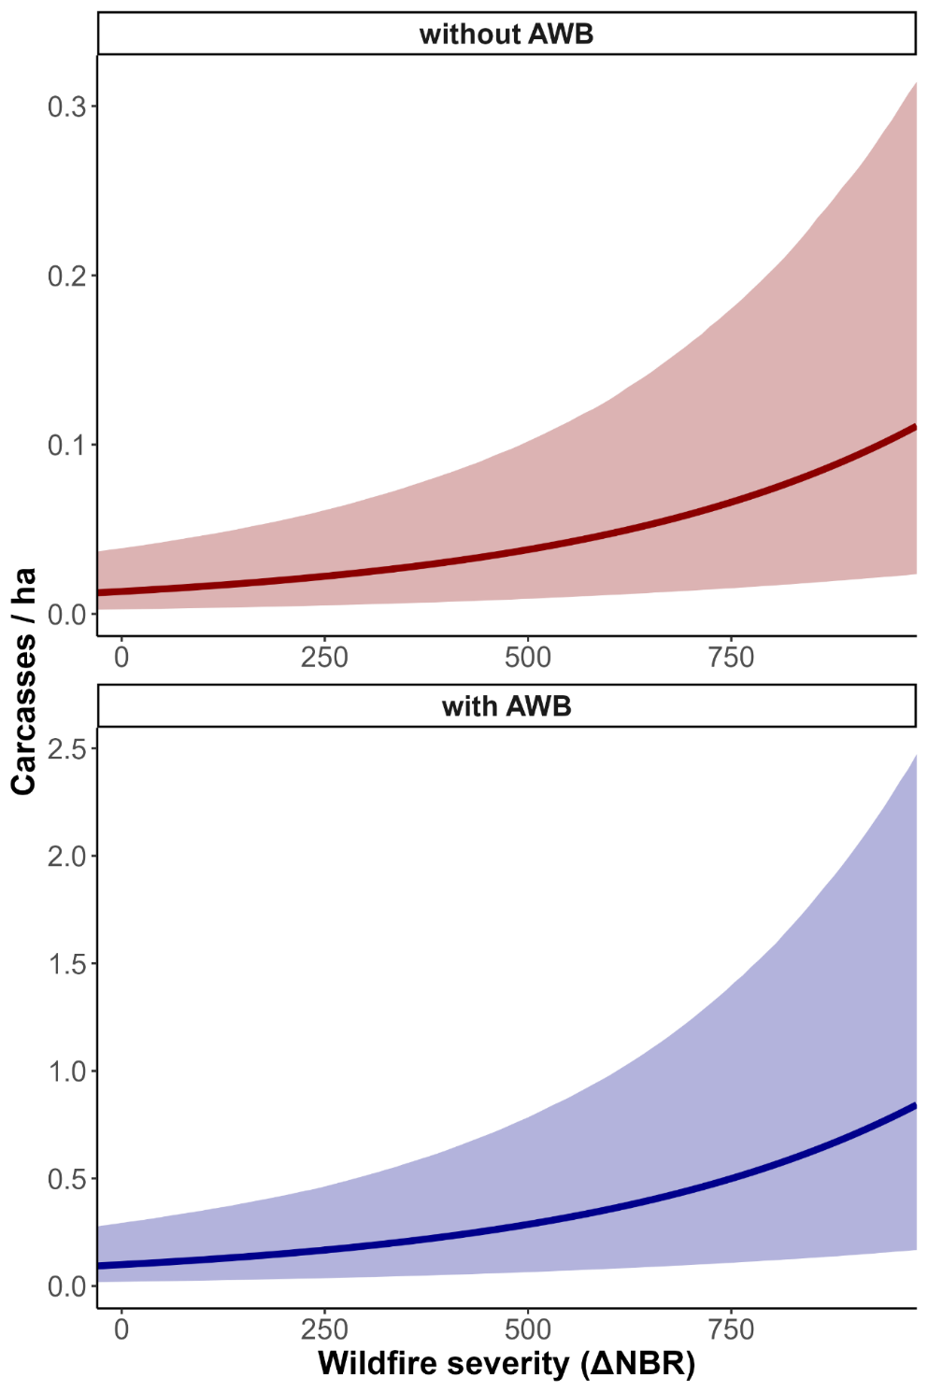

**Figure 3.** Estimated number of carcasses of medium and large size mammals in relation to wildfire severity for sites with and without artificial water bodies (AWB). Note that y-axes are in different scales.

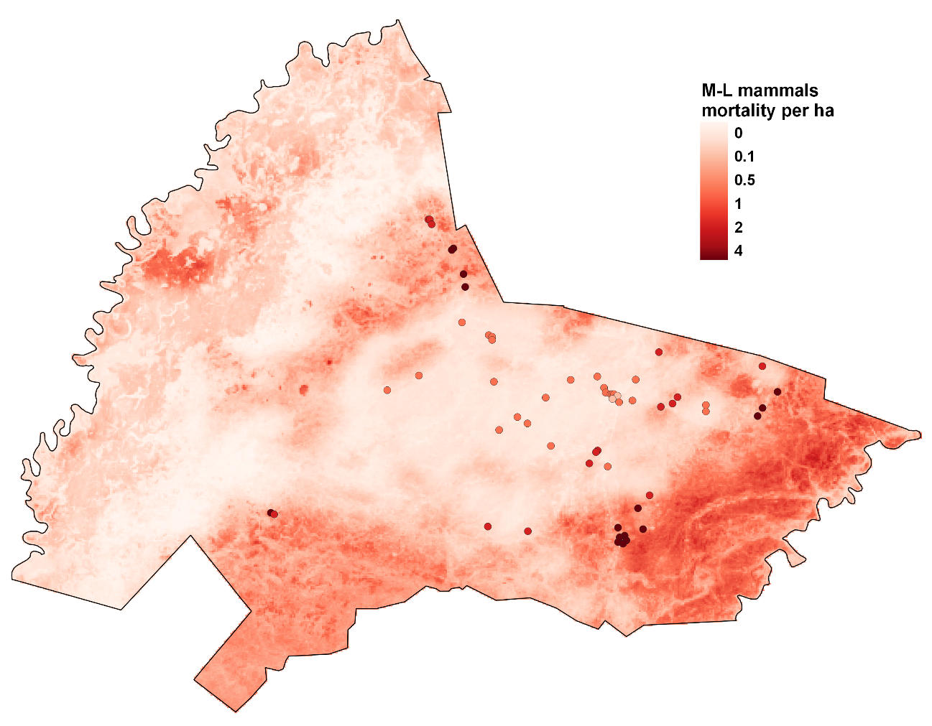

**Figure 4.** Spatial prediction of medium-large size mammals’ mortalities after the Pantanal 2020 megafires at the Sesc Pantanal Reserve, Brazil. Points represent artificial water bodies (AWB) where mortality was higher.

**DISCUSSION**

In this study, we have used direct carcass counts to assess the spatial variation of mortalities of medium- and large-sized mammals caused by the 2020 Pantanal megafires, accounting for imperfect detection during surveys. Double-observer carcass counts of multiple species analyzed with hierarchical N-mixture models can provide an interesting framework to model mortality by wildfires. With this approach, we were able to assess mortality patterns for the “community” of medium- and large-sized mammals, as well as for some specific species. As far as we know, this study is the first attempt to model spatial heterogeneity of direct wildfire mortalities from carcass surveys. Interestingly, we were able to reveal the influence of aspects related to both species-habitat relationships and wildfire characteristics on the spatial variation of deaths by fires. We estimated that tens of thousands (~50k) of medium- and large-sized mammals of around 26 species died from these catastrophic wildfires in the Sesc Pantanal Reserve that burnt more than 90% of its area in 2020. Spatial patterns of mortality abundance and richness were generally related to non-flooded forests, the presence of artificial water bodies, and the severity of the wildfire. We have not found an influence of the availability of water bodies (rivers, creeks, and lakes) on the distribution of carcasses. Also, there was no influence of obstructing green vegetation on carcass detection by the observers during surveys.

Although the direct impacts of fires on animal populations are expected to be usually low (Jolly et al., 2022), the effects of Pantanal 2020 megafires on the populations of some mammal species might have been very impactful since the estimated numbers of mammalian deaths reported here were substantially high. The general mortality estimate we found (Table 1) is not significantly different from the ones obtained by Tomas et al. (2021) for medium-large sized vertebrates in a larger region of Pantanal. However, our estimates may represent higher numbers for medium- and large-sized mammals if we consider that Tomas and colleagues (2021) included other common vertebrate taxa (e.g., caimans, turtles, and birds; >2kg). Comparing the mortality estimates with density estimates found in the literature for Pantanal, the studied species here can be roughly categorized into three classes: i) alarming mortality numbers similar or even higher to published population densities (tapirs, Desbiez et al., 2009; Trolle et al., 2008; Southern tamanduas, Desbiez et al., 2010; and agoutis, Desbiez et al., 2009); ii) mortality estimates around half or two thirds of known population densities (brocket deer and white-lipped peccaries, Desbiez et al., 2009); and iii) mortalities representing about one- third of known densities (collared peccaries and capybaras, Desbiez et al., 2009; capuchin monkeys, Aguiar et al., 2011). Six out of the 27 species of the regional pool known to occur at the studied reserve are considered globally threatened with extinction (Table S1). Of those, the capuchin monkey (*Sapajus cay*), the white-lipped peccary (*Tayassu pecari*), and the tapir (*Tapirus terrestris*) have been substantially affected by the 2020 megafires and should receive special attention in the following years. We note that, if one considers the posterior deaths due to starvation, thirst, infections, pulmonary diseases, and exposure to predators, the total mortality estimates could be much higher.

Non-flooded forests, especially the seasonally dry forests, are environments rich in mammal species in the Pantanal (Desbiez et al., 2009; Keuroghlian et al., 2009; Regolin et al., 2021) and presented the highest susceptibilities for mortalities by the megafires. The landscape in the Pantanal wetland, strongly determined by flooding regimes and soil types, tends to be very heterogeneous, hence the susceptibility of the different vegetation types to fire (Arruda et al., 2016; Pivello et al., 2021). While open-vegetation areas (grasslands, shrublands, and “cerrado”) are more prone and adapted to wildfires, forests are more sensitive and present a lower proportion of resistant plants (Martins et al., 2022; Pivello et al., 2021). Furthermore, forest areas are a more humid environment that commonly do not burn or, at least, they suffer from small flames through the dried leaf litter (Pivello et al., 2021). Hence, extreme megafire events make these forest environments particularly vulnerable to their impacts. Capybara (*H. hydrochaeris*) was the only species negatively affected by the proportion of non-flooded forests. This situation could be expected, since they occur more densely in the region with more permanent water bodies surrounded by seasonally flooded forests and shrublands (Desbiez et al., 2009). Noteworthy, almost all the nine most directly affected species (capuchin monkeys, tapirs, white-lipped and collared peccaries, and agouties) depend considerably on forest resources to feed on (i.e., seed and fruits) and may have suffered indirect effects, such as starvation. Mature forests demand time to regenerate and then provide fruits and seeds. Therefore, these mammals that depend on forest resources might struggle with a long-lasting scarcity after megafires and the recovery of these populations may last years.

The severity of the wildfires (calculated by differences in the vegetation pre- and post-fire) has significantly impacted the amount of mammalian deaths. While unburnt sites presented virtually zero mortality estimates, areas with high wildfire severity showed an average of ten mammalian carcasses per km². Common strategies of escaping or taking refuge used by mammalian species can be efficient under wildfires with lower magnitudes but may be useless in megafires contexts (Nimmo et al., 2021). Hence, the relationship between mortality numbers and wildfire severity is probably a result of inefficient behavior responses to fires. Furthermore, the effects of wildfire severity might have been exacerbated in forest areas since these habitats are not used to burn with high severity. For example, among the most affected species, capuchin monkeys, tamanduas, and coatis can present an escaping behavior during fires by climbing trees. However, under conditions of high flames, this strategy becomes a death trap. Finally, as wildfire severity can also be related to the availability of dry matter, some management strategies in certain areas could be employed to reduce the biomass available to burn, such as prescribed managed burns (Berlinck et al., 2022).

Artificial water bodies (AWB) have concentrated a high number of deaths, presenting mortality estimates 7.5 times greater compared to similar sites without these structures. AWB are typical structures in Pantanal since the main activity in the region is cattle ranching (Seidl et al., 2001). These artificial small lakes are usually built in drier areas to provide water for livestock in the dry season, as this period can be very restrictive. Native mammals also widely use AWB, especially in the dry season, and may have these areas as safe places to take refuge. However, as AWB tend to dry up in periods of severe drought, individuals that seek refuge in these areas during wildfires can end up in a trap. On the other hand, we have not found an effect of the distance to permanent water bodies on the distribution of carcasses. Although water bodies can act as a refuge for mammals during wildfires, this role could have been compromised since 93% of the studied area was burnt.

One major limitation of the approaches that assess wildfire mortality impacts only using carcass surveys is that they provide restricted inferences about the magnitude of the effect on local populations. To assess the effects of wildfires on the dynamics of populations, studies commonly compare populational data (e.g., occupancy or abundance) collected before and after fires and/or in burnt and unburnt areas (Southwell et al., 2022). In such approaches, differences in the population state variable (occupancy or abundance) can result from mortalities due to direct deaths by fires, indirect effects (e.g., starvation or reduced fitness), or emigration processes. However, since wildfires are frequently related to extreme weather events (e.g., droughts), it is difficult to interpret how demographic parameters are affected, specifically by wildfires or a combination of events. The Bayesian hierarchical modeling approach used here provides a flexible and expandable framework that allows integrating carcass surveys with populational data to model these underlying processes jointly (Isaac et al., 2020; Zipkin & Saunders, 2018). For example, by combining demographic data pre- and post-wildfires with carcass counts, it would be possible to disentangle the contribution of direct deaths from other mortality or emigration processes in the population dynamics.

*Conservation and management implications*

Extreme weather events resulting from global climate changes are becoming more common worldwide. With the combination of climatic extremes and the recent tendencies of anthropic pressure intensification in Pantanal, megafires, such as in the 2020’s, are expected to occur more frequently (Ferreira Barbosa et al., 2022; Leal Filho et al., 2021; Marques et al., 2021). Since Pantanal is an essential sanctuary for several threatened wildlife species, the public policy agenda needs to include conservation efforts for medium- and large-sized mammal species, such as evaluations and prediction of the impacts of wildfire events. We have shown that the direct mortality of mammals by wildfires is affected by landscape factors related to species habitats, species traits (probably related to escape or refuge strategies) and also the intensity of the wildfires. Hence, conservation and management actions to prevent or minimize wildfire impacts should consider these three aspects.

Pantanal forested habitats (particularly non-flooded areas), that are enclaves of fire-sensitive vegetation (Pivello et al., 2021), need special attention in management plans for fire prevention and fighting since they tend to concentrate more deaths. Artificial water bodies, a prevalent landscape structure in Pantanal, deserve a particular focus in prevention actions. For example, by avoiding wildfires from reaching these areas or protecting possible corridors (e.g., local roads) to permit escape routes. The high proportion of private ranches (~93%) and the lack of protected areas in Pantanal (Tomas *et al*., 2019), can be a suitable context for starting and spreading wildfires. Thus, effective fire management plans would pass by combining management actions with private landowners, especially those surrounding protected areas. To be effective, a fire management plan should adopt the Mitigation Hierarchy, a framework widely applied to address impacts of economic activities, but that need to be extended to all negative anthropogenic impacts on biodiversity (Arlidge et al., 2018). This framework states that, only after exhausting options of actions to avoid the impacts of an anthropogenic activity, one would plan complementary actions to, respectively, minimize, recover, and compensate the remaining impacts. Such plans, following the Mitigation Hierarchy, can be greatly improved in efficient when designed with spatial prioritization (Sakti et al., 2022).

We found nine mammalian species that have presented considerably high numbers of mortalities (>1,900), three of them considered threatened with extinction (capuchin monkeys, white-lipped peccaries, and tapirs) that should have noteworthy attention to monitor their recovery and future population tendencies. Also, those species strongly dependent on forest food resources demand extra consideration in the recovery monitoring programs. Finally, we point out that, although surveying and monitoring populations are essential ways to evaluate the impacts of wildfires, assessing mortality patterns (by directly counting the dead) is crucial to understand the effects of megafires. Assessing spatial patterns of wildfire animal mortalities in landscapes is of uttermost importance for anticipating the effects of future fires and planning prevention or mitigation actions, such as identifying critical areas for firefighting or animal rescue.

**REFERENCES**

Aguiar, L. M., Ludwig, G., Roper, J. J., Svoboda, W. K., Navarro, I. T., & Passos, F. C. (2011). Howler and Capuchin Monkey Densities in Riparian Forests on Islands and Adjacent Shores on the Upper Paraná River, Southern Brazil. *Neotropical Primates*, *18*(2), 39–43. https://doi.org/10.1896/044.018.0201

Alho, CJR., Camargo, G., & Fischer, E. (2011). Terrestrial and aquatic mammals of the Pantanal. *Brazilian Journal of Biology*, *71*(1), 297–310. https://doi.org/10.1590/S1519-69842011000200009

Arlidge, W. N. S., Bull, J. W., Addison, P. F. E., Burgass, M. J., Gianuca, D., Gorham, T. M., Jacob, C. D. S., Shumway, N., Sinclair, S. P., Watson, J. E. M., Wilcox, C., & Milner-Gulland, E. J. (2018). A Global Mitigation Hierarchy for Nature Conservation. In *BioScience* (Vol. 68, Issue 5, pp. 336–347). Oxford University Press. https://doi.org/10.1093/biosci/biy029

Arruda, W. de S., Oldeland, J., Paranhos Filho, A. C., Pott, A., Cunha, N. L., Ishii, I. H., & Damasceno-Junior, G. A. (2016). Inundation and Fire Shape the Structure of Riparian Forests in the Pantanal, Brazil. *PLOS ONE*, *11*(6), e0156825. https://doi.org/10.1371/journal.pone.0156825

Berlinck, C. N., Lima, L. H. A., Pereira, A. M. M., Carvalho Jr, E. A. R., Paula, R. C., Thomas, W. M., & Morato, R. G. (2022). The Pantanal is on fire and only a sustainable agenda can save the largest wetland in the world. *Brazilian Journal of Biology*, *82*, 2–3. https://doi.org/10.1590/1519-6984.244200

Cid, B., Oliveira-Santos, L. G. R., & Mourão, G. (2013). Seasonal Habitat Use of Agoutis ( *Dasyprocta azarae* ) is Driven by the Palm *Attalea phalerata* in Brazilian Pantanal. *Biotropica*, *45*(3), 380–385. https://doi.org/10.1111/btp.12012

Dénes, F. V., Silveira, L. F., & Beissinger, S. R. (2015). Estimating abundance of unmarked animal populations: Accounting for imperfect detection and other sources of zero inflation. *Methods in Ecology and Evolution*, *6*(5), 543–556. https://doi.org/10.1111/2041-210X.12333

Desbiez, A. L. J., Bodmer, R. E., & Aparecida, S. (2009). Wildlife habitat selection and sustainable resources management in a Neotropical wetland. *International Journal of Biodiversity and Conservation*, *1*(1), 11–20.

Desbiez, A. L. J., Bodmer, R. E., & Tomas, W. M. (2010). Mammalian Densities in a Neotropical Wetland Subject to Extreme Climatic Events. *Biotropica*, *42*(3), 372–378. https://doi.org/10.1111/j.1744-7429.2009.00601.x

Dorazio, R. M., Royle, J. A., Söderström, B., & Glimskär, A. (2006). Estimating species richness and accumulation by modeling species occurrence and detectability. *Ecology*, *87*(4), 842–854. https://doi.org/https://doi.org/10.1890/0012-9658(2006)87[842:ESRAAB]2.0.CO;2

Driscoll, D. A., Lindenmayer, D. B., Bennett, A. F., Bode, M., Bradstock, R. A., Cary, G. J., Clarke, M. F., Dexter, N., Fensham, R., Friend, G., Gill, M., James, S., Kay, G., Keith, D. A., MacGregor, C., Russell-Smith, J., Salt, D., Watson James, J. E. M., Williams Richard J., R. J., & York, A. (2010). Fire management for biodiversity conservation: Key research questions and our capacity to answer them. *Biological Conservation*, *143*(9), 1928–1939. https://doi.org/10.1016/j.biocon.2010.05.026

Duane, A., Castellnou, M., & Brotons, L. (2021). Towards a comprehensive look at global drivers of novel extreme wildfire events. *Climatic Change*, *165*(3–4), 43. https://doi.org/10.1007/s10584-021-03066-4

Engstrom, R. T. (2010). First-Order Fire Effects on Animals: Review and Recommendations. *Fire Ecology*, *6*(1), 115–130. https://doi.org/10.4996/fireecology.0601115

Ferreira Barbosa, M. L., Haddad, I., da Silva Nascimento, A. L., Máximo da Silva, G., Moura da Veiga, R., Hoffmann, T. B., Rosane de Souza, A., Dalagnol, R., Susin Streher, A., Souza Pereira, F. R., Oliveira e Cruz de Aragão, L. E., & Oighenstein Anderson, L. (2022). Compound impact of land use and extreme climate on the 2020 fire record of the Brazilian Pantanal. *Global Ecology and Biogeography*, *31*(10), 1960–1975. https://doi.org/10.1111/geb.13563

Garcia, L. C., Szabo, J. K., de Oliveira Roque, F., de Matos Martins Pereira, A., Nunes da Cunha, C., Damasceno-Júnior, G. A., Morato, R. G., Tomas, W. M., Libonati, R., & Ribeiro, D. B. (2021). Record-breaking wildfires in the world’s largest continuous tropical wetland: Integrative fire management is urgently needed for both biodiversity and humans. *Journal of Environmental Management*, *293*(September 2020), 112870. https://doi.org/10.1016/j.jenvman.2021.112870

Hofmann, G. S., Coelho, I. P., Bastazini, V. A. G., Cordeiro, J. L. P., & de Oliveira, L. F. B. (2016). Implications of climatic seasonality on activity patterns and resource use by sympatric peccaries in northern Pantanal. *International Journal of Biometeorology*, *60*(3), 421–433. https://doi.org/10.1007/s00484-015-1040-8

Isaac, N. J. B., Jarzyna, M. A., Keil, P., Dambly, L. I., Boersch-Supan, P. H., Browning, E., Freeman, S. N., Golding, N., Guillera-Arroita, G., Henrys, P. A., Jarvis, S., Lahoz-Monfort, J., Pagel, J., Pescott, O. L., Schmucki, R., Simmonds, E. G., & O’Hara, R. B. (2020). Data Integration for Large-Scale Models of Species Distributions. *Trends in Ecology & Evolution*, *35*(1), 56–67. https://doi.org/10.1016/j.tree.2019.08.006

Jolly, C. J., Dickman, C. R., Doherty, T. S., van Eeden, L. M., Geary, W. L., Legge, S. M., Woinarski, J. C. Z., & Nimmo, D. G. (2022). Animal mortality during fire. *Global Change Biology*, *28*(6), 2053–2065. https://doi.org/10.1111/gcb.16044

Jolly, W. M., Cochrane, M. A., Freeborn, P. H., Holden, Z. A., Brown, T. J., Williamson, G. J., & Bowman, D. M. J. S. (2015). Climate-induced variations in global wildfire danger from 1979 to 2013. *Nature Communications*, *6*(1), 7537. https://doi.org/10.1038/ncomms8537

Junk, W. J., Da Cunha, C. N., Wantzen, K. M., Petermann, P., Strüssmann, C., Marques, M. I., & Adis, J. (2006). Biodiversity and its conservation in the Pantanal of Mato Grosso, Brazil. *Aquatic Sciences*, *68*(3), 278–309. https://doi.org/10.1007/s00027-006-0851-4

Kellner, K. F. (2015). *jagsUI: A Wrapper Around rjags to Streamline JAGS Analyses. R package version 1.3.1*.

Kéry, M., & Royle, J. A. (2016). *Applied hierarchical modeling in ecology, volume 1 (Prelude and Static model)*. Academic Press.

Keuroghlian, A., Eaton, D. P., & Desbiez, A. L. J. (2009). The response of a landscape species, white-lipped peccaries, to seasonal resource fluctuations in a tropical wetland, the Brazilian pantanal. *International Journal of Biodiversity and Conservation*, *1*(4), 087–097. https://doi.org/https://doi.org/10.5897/IJBC.9000140

Leal Filho, W., Azeiteiro, U. M., Salvia, A. L., Fritzen, B., & Libonati, R. (2021). Fire in Paradise: Why the Pantanal is burning. *Environmental Science & Policy*, *123*, 31–34. https://doi.org/10.1016/j.envsci.2021.05.005

Lefebvre, Davranche, Willm, Campagna, Redmond, Merle, Guelmami, & Poulin. (2019). Introducing WIW for Detecting the Presence of Water in Wetlands with Landsat and Sentinel Satellites. *Remote Sensing*, *11*(19), 2210. https://doi.org/10.3390/rs11192210

Libonati, R., Belém, L., Lemos, F., Sena, C., Carvalho, I., & Pinto, M. (2021). *Nota Técnica 01/2021 LASA-UFRJ Queimadas Pantanal 2020*. *March*. https://doi.org/10.13140/RG.2.2.11629.51687

Libonati, R., DaCamara, C. C., Peres, L. F., Sander de Carvalho, L. A., & Garcia, L. C. (2020). Rescue Brazil’s burning Pantanal wetlands. *Nature*, *588*(7837), 217–219. https://doi.org/10.1038/d41586-020-03464-1

Linley, G. D., Jolly, C. J., Doherty, T. S., Geary, W. L., Armenteras, D., Belcher, C. M., Bliege Bird, R., Duane, A., Fletcher, M., Giorgis, M. A., Haslem, A., Jones, G. M., Kelly, L. T., Lee, C. K. F., Nolan, R. H., Parr, C. L., Pausas, J. G., Price, J. N., Regos, A., … Nimmo, D. G. (2022). What do you mean, ‘megafire’? *Global Ecology and Biogeography*, *31*(10), 1906–1922. https://doi.org/10.1111/geb.13499

Marengo, J. A., Oliveira, G. S., & Alves, L. M. (2016). Climate Change Scenarios in the Pantanal. In I. Bergier & M. L. Assine (Eds.), *Dynamics of the Pantanal Wetland in South America* (pp. 227–238). Springer. https://doi.org/10.1007/698_2015_357

Marques, J. F., Alves, M. B., Silveira, C. F., Amaral e Silva, A., Silva, T. A., dos Santos, V. J., & Calijuri, M. L. (2021). Fires dynamics in the Pantanal: Impacts of anthropogenic activities and climate change. *Journal of Environmental Management*, *299*(March), 113586. https://doi.org/10.1016/j.jenvman.2021.113586

Martins, P. I., Belém, L. B. C., Szabo, J. K., Libonati, R., & Garcia, L. C. (2022). Prioritising areas for wildfire prevention and post-fire restoration in the Brazilian Pantanal. *Ecological Engineering*, *176*(December 2021). https://doi.org/10.1016/j.ecoleng.2021.106517

Menezes, L. S., de Oliveira, A. M., Santos, F. L. M., Russo, A., de Souza, R. A. F., Roque, F. O., & Libonati, R. (2022). Lightning patterns in the Pantanal: Untangling natural and anthropogenic-induced wildfires. *Science of The Total Environment*, *820*, 153021. https://doi.org/10.1016/j.scitotenv.2022.153021

Muñoz, A. P., Kéry, M., Martins, P. V., & Ferraz, G. (2018). Age effects on survival of Amazon forest birds and the latitudinal gradient in bird survival. *The Auk*, *135*(2), 299–313. https://doi.org/10.1642/auk-17-91.1

Nimmo, D. G., Carthey, A. J. R., Jolly, C. J., & Blumstein, D. T. (2021). Welcome to the Pyrocene: Animal survival in the age of megafire. *Global Change Biology*, *27*(22), 5684–5693. https://doi.org/10.1111/gcb.15834

Patrignani, A., & Ochsner, T. E. (2015). Canopeo: A Powerful New Tool for Measuring Fractional Green Canopy Cover. *Agronomy Journal*, *107*(6), 2312–2320. https://doi.org/10.2134/agronj15.0150

Pausas, J. G., & Keeley, J. E. (2009). A Burning Story: The Role of Fire in the History of Life. *BioScience*, *59*(7), 593–601. https://doi.org/10.1525/bio.2009.59.7.10

Pausas, J. G., & Keeley, J. E. (2021). Wildfires and global change. *Frontiers in Ecology and the Environment*, *19*(7), 387–395. https://doi.org/10.1002/fee.2359

Pivello, V. R., Vieira, I., Christianini, A. V, Bandini, D., Menezes, S., Niel, C., Melo, F. P. L., Antonio, J., Gustavo, C., Moraes, W., & Overbeck, G. E. (2021). Understanding Brazil ’ s catastrophic fires : Causes , consequences and policy needed to prevent future tragedies. *Perspectives in Ecology and Conservation*, *19*(3), 233–255. https://doi.org/10.1016/j.pecon.2021.06.005

Plummer, M. (2003). *JAGS: A Program for Analysis of Bayesian Graphical Models Using Gibbs Sampling*.

R Core Team. (2022). *R: a Language and Environment for Statistical Computing*.

Regolin, A. L., Oliveira-Santos, L. G., Ribeiro, M. C., & Bailey, L. L. (2021). Habitat quality, not habitat amount, drives mammalian habitat use in the Brazilian Pantanal. *Landscape Ecology*, *36*(9), 2519–2533. https://doi.org/10.1007/s10980-021-01280-0

Robinson, N. M., Leonard, S. W. J., Ritchie, E. G., Bassett, M., Chia, E. K., Buckingham, S., Gibb, H., Bennett, A. F., & Clarke, M. F. (2013). *Refuges for fauna in fire-prone landscapes : their ecological function and importance*. 1321–1329. https://doi.org/10.1111/1365-2664.12153

Sakti, A. D., Fauzi, A. I., Takeuchi, W., Pradhan, B., Yarime, M., Vega-Garcia, C., Agustina, E., Wibisono, D., Anggraini, T. S., Theodora, M. O., Ramadhanti, D., Muhammad, M. F., Aufaristama, M., Perdana, A. M. P., & Wikantika, K. (2022). Spatial Prioritization for Wildfire Mitigation by Integrating Heterogeneous Spatial Data: A New Multi-Dimensional Approach for Tropical Rainforests. *Remote Sensing*, *14*(3). https://doi.org/10.3390/rs14030543

Seidl, A. F., De Silva, J. D. S. V., & Moraes, A. S. (2001). Cattle ranching and deforestation in the Brazilian Pantanal. *Ecological Economics*, *36*(3), 413–425. https://doi.org/10.1016/S0921-8009(00)00238-X

Southwell, D., Legge, S., Woinarski, J., Lindenmayer, D., Lavery, T., & Wintle, B. (2022). Design considerations for rapid biodiversity reconnaissance surveys and long‐term monitoring to assess the impact of wildfire. *Diversity and Distributions*, *28*(3), 559–570. https://doi.org/10.1111/ddi.13427

Stuber, E. F., Gruber, L. F., & Fontaine, J. J. (2017). A Bayesian method for assessing multi-scale species-habitat relationships. *Landscape Ecology*, *32*(12), 2365–2381. https://doi.org/10.1007/s10980-017-0575-y

Tomas, W. M., Berlinck, C. N., Chiaravalloti, R. M., Faggioni, G. P., Strüssmann, C., Libonati, R., Abrahão, C. R., do Valle Alvarenga, G., de Faria Bacellar, A. E., de Queiroz Batista, F. R., Bornato, T. S., Camilo, A. R., Castedo, J., Fernando, A. M. E., de Freitas, G. O., Garcia, C. M., Gonçalves, H. S., de Freitas Guilherme, M. B., Layme, V. M. G., … Morato, R. (2021). Distance sampling surveys reveal 17 million vertebrates directly killed by the 2020’s wildfires in the Pantanal, Brazil. *Scientific Reports*, *11*(1), 23547. https://doi.org/10.1038/s41598-021-02844-5

Trolle, M., Noss, A. J., Cordeiro, J. L. P., & Oliveira, L. F. B. (2008). Brazilian Tapir Density in the Pantanal: A Comparison of Systematic Camera-Trapping and Line-Transect Surveys. *Biotropica*, *40*(2), 211–217. https://doi.org/10.1111/j.1744-7429.2007.00350.x

Ward, M., Carwardine, J., Watson, J. E. M., Pintor, A., Stuart, S., Possingham, H. P., Rhodes, J. R., Carey, A. R., Auerbach, N., Reside, A., Yong, C. J., & Tulloch, A. I. T. (2022). How to prioritize species recovery after a megafire. *Conservation Biology*, *36*(5), 1–16. https://doi.org/10.1111/cobi.13936

Yamaura, Y., Kéry, M., & Andrew Royle, J. (2016). Study of biological communities subject to imperfect detection: bias and precision of community N-mixture abundance models in small-sample situations. *Ecological Research*, *31*(3), 289–305. https://doi.org/10.1007/s11284-016-1340-4

Zipkin, E. F., & Saunders, S. P. (2018). Synthesizing multiple data types for biological conservation using integrated population models. *Biological Conservation*, *217*(October 2017), 240–250. https://doi.org/10.1016/j.biocon.2017.10.017